Safir
Xi tkj

Install dhcp dengan code:
sudo apt install isc-dhcp-server

edit setingan dhcp dengan code:
sudo nano /etc/dhcp/dhcpd.conf
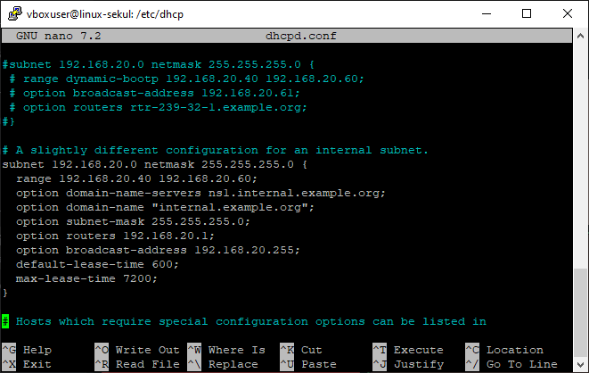

192.168.20.0 = network ID
255.255.255.0 = netmask
range 192.168.20.40 192.168.20.60; = range ip client
option subnet-mask 255.255.255.0; = subnet mask ip client
Seting interface yang di pake
Sudo nano /etc/default/isc-dhcp-server
option routers 192.168.20.1; = gateway client
option broadcast-address 192.168.20.255; = ip broadcast
default-lease-time 600; = waktu client memakai ip nya
max-lease-time 7200; = waktu maksimal client memakai ip
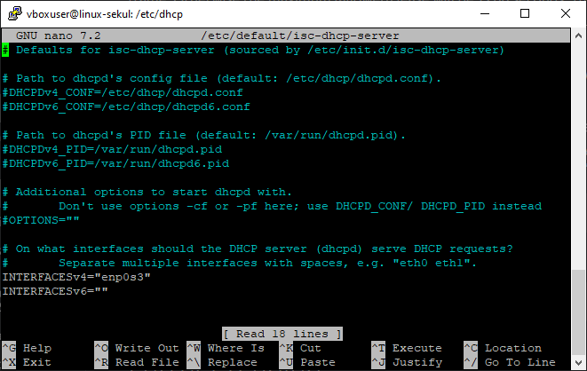
Selanjut nya restart dhcp dengan code
sudo systemctl restart isc-dhcp-server.service

buka windows 10 di vm sebagai cient lalu cek ip dengan code
ipconfig
